# Case Study: PWTorch/MMATorch

*Last Updated: November 19, 2008*

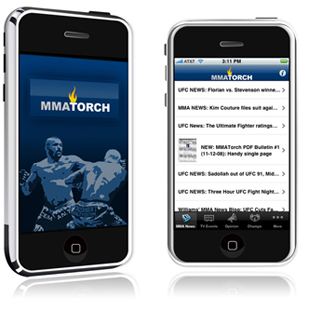

First launched as a print newsletter in 1987, for over 20 years the Torch has been at the forefront of providing pro wrestling and mixed martial arts information utilizing the latest cutting-edge technology: print newsletter, 900 line updates, websites, email reports, podcasting, and now mobile. PWTorch.com and MMATorch.com are leading sources for daily news update, provocative expert points of view, and exclusive interviews. Powered by an experienced team of professional reporters and columnists, the Torch is a recognized source for the very best coverage of the always-fascinating and controversial pro wrestling industry as well as the rapidly growing sport of mixed martial arts.

**The Challenge**

PWTorch and MMATorch are expected to keep fans up-to-the-moment online with live TV and Pay-Per-View events as they happen, providing exclusive interviews with top stars in the sport, and delivering expert news, opinion and commentary.

To move this experience to the mobile world, a technology was needed that could deliver the latest content available online, formatted and optimized for mobile consumers across all their devices, including the latest iPhone and Android mobile platforms. The technology would need to enable the best available user experience on every mobile platform from mobile widgets and browsers to full-featured mobile applications.

**The Solution**

Recognized as a leader in user experience, UIEvolution designed, developed and now host PWTorch and MMATorch Mobile. Using the UIEvolution Blender™ software service, the Torch delivers the very latest breaking pro wrestling and mixed martial arts news, live pay-per-view results, exclusive audio updates, and thought-provoking columns from the Torch staff of writers to fans away from their computers.

UIEvolution provided the Torch with an end-to-end solution in only one week that included not only standard mobile browser widgets, but rich applications for devices like the iPhone. Fans on the go will now find PWTorch and MMATorch content by going to the Apple iPhone App Store, by simply entering the website into their mobile browser, or by sending a direct link to their phone via SMS from the web.

When fans launch PWTorch and MMATorch on their mobile devices they have immediate access to a streamlined sports experience that hands them the latest news. Now they can follow UFC pay-per-view results while at the airport, read the latest column while on a break at work, or listen to the latest Penick Audio Update while stuck in traffic, all easier than ever with a high-end mobile-specific interface design by UIEvolution Design Services.

**The Result**

With the new PWTorch and MMATorch “Form meets function… Content meets accessibility… All in the palm of your hand” says Wade Keller, Editor & Chief of the Torch. With some of the biggest brands and media companies around the world already using UIEvolution technology to power mobile experiences, PWTorch and MMATorch join a rich collection of applications that engage and excite millions of customers every day. These Torch properties are now mobile, covering the biggest promotions and events around the world, UFC, WEC, Pride, IFL, Affliction, and more. PWTorch and MMATorch feature profiles, news and interviews with the biggest stars in the pro wrestling and mixed martial arts sports entertainment industry. Fans can catch up on past events and DVD releases with full event coverage and reviews, down to every detail from the mat.